Perry ELEC3400 Output Stage Calculations

Version 1.0

# PNP DC OFFSET

## 1.1) Initial Calculations

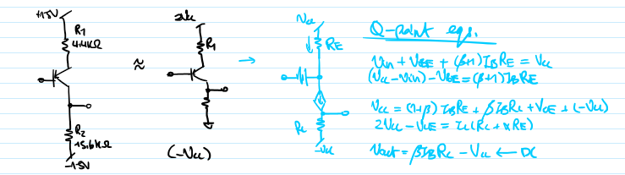

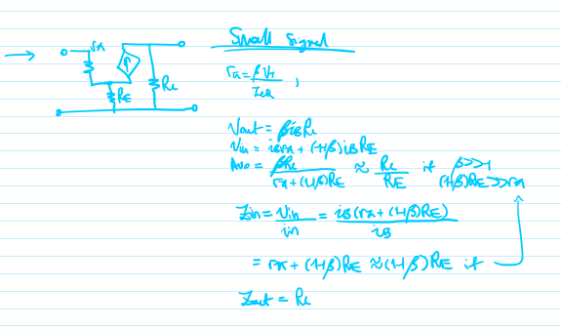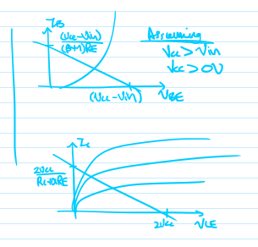

## 1.2) Component Choice Final and Q Point

<https://www.onsemi.com/pdf/datasheet/2n3906-d.pdf>

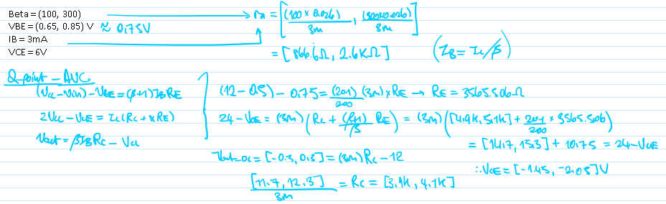

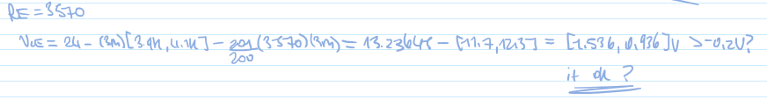

## 1.3) Final Characteristics and Summary

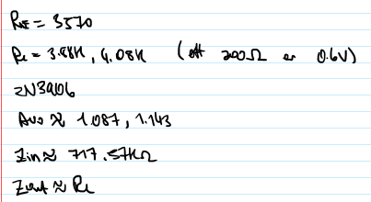

## 1.4) Simulation

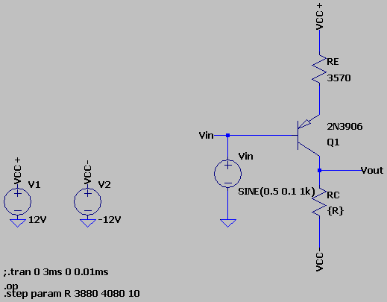

Figure 1: LTSPICE Model

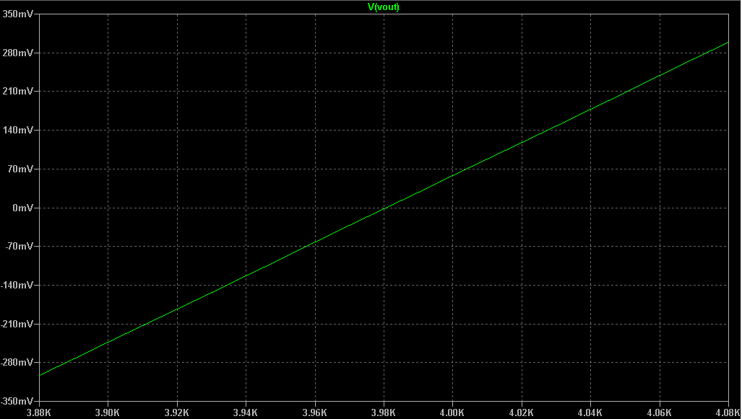

Figure 2: DC Offset Based on Changes to RC

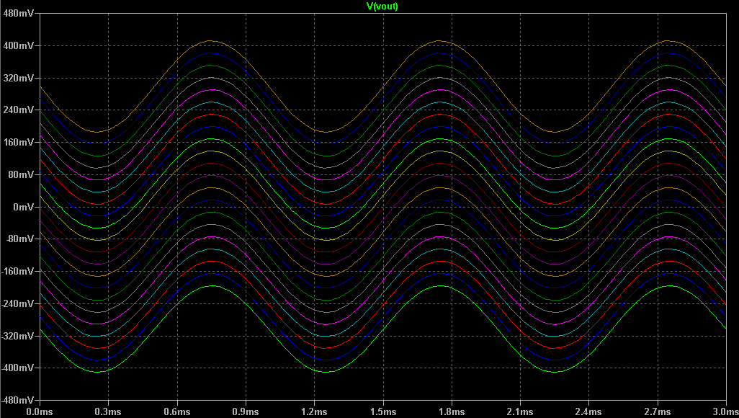

Figure 3: Final Outputs of Vout with DC Offsets

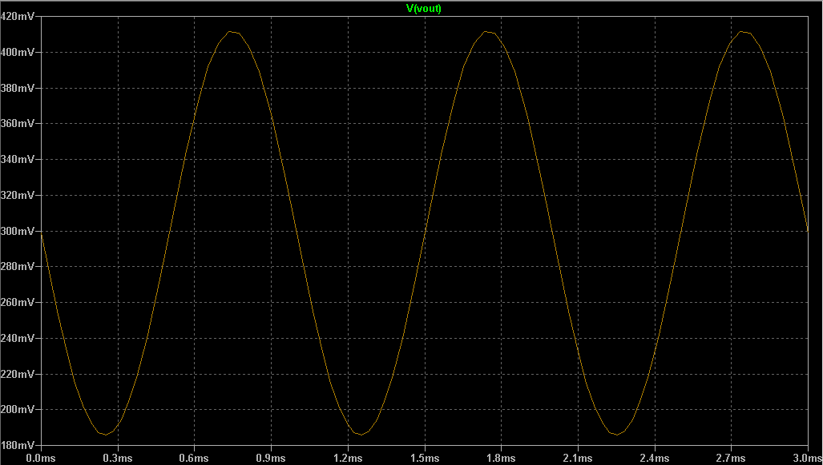

Figure 4: Close Up of RC = 4.08kR, 0.3V DC Offset

## 1.5) Key Takeaways

* This design works.
* Has a high output impedance however will require a buffer on the next stage.

# 2) AB Push Pull Amplifiers

## 2.1) Understanding Push Pulls and Initial Parameters

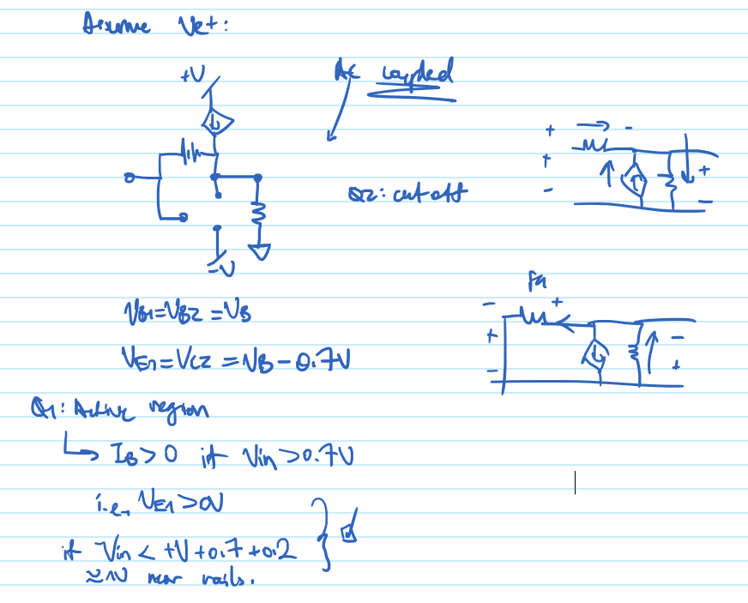

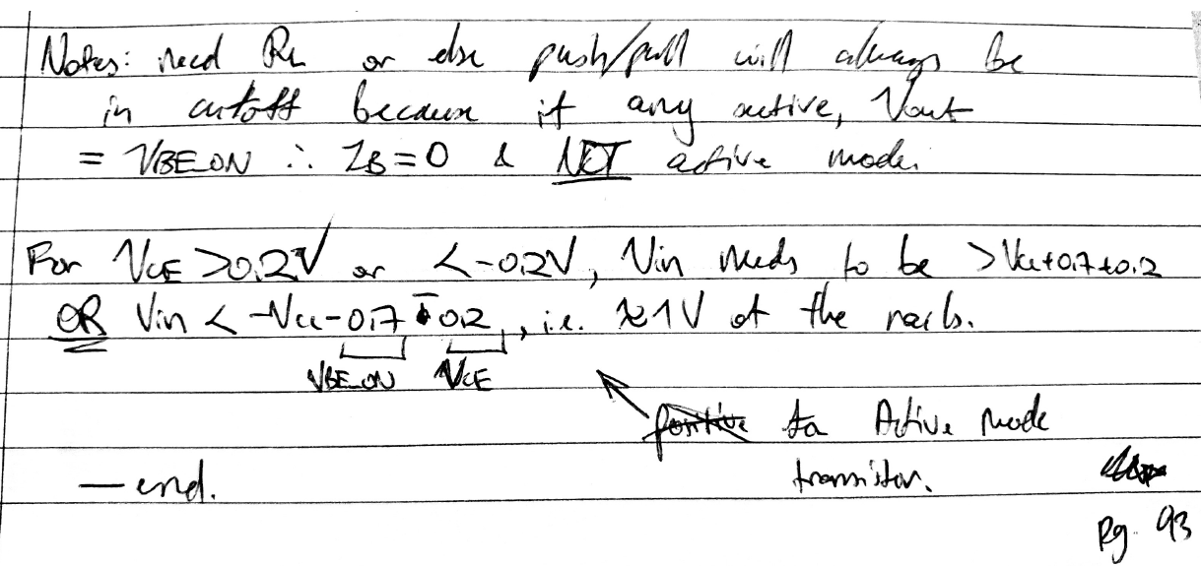

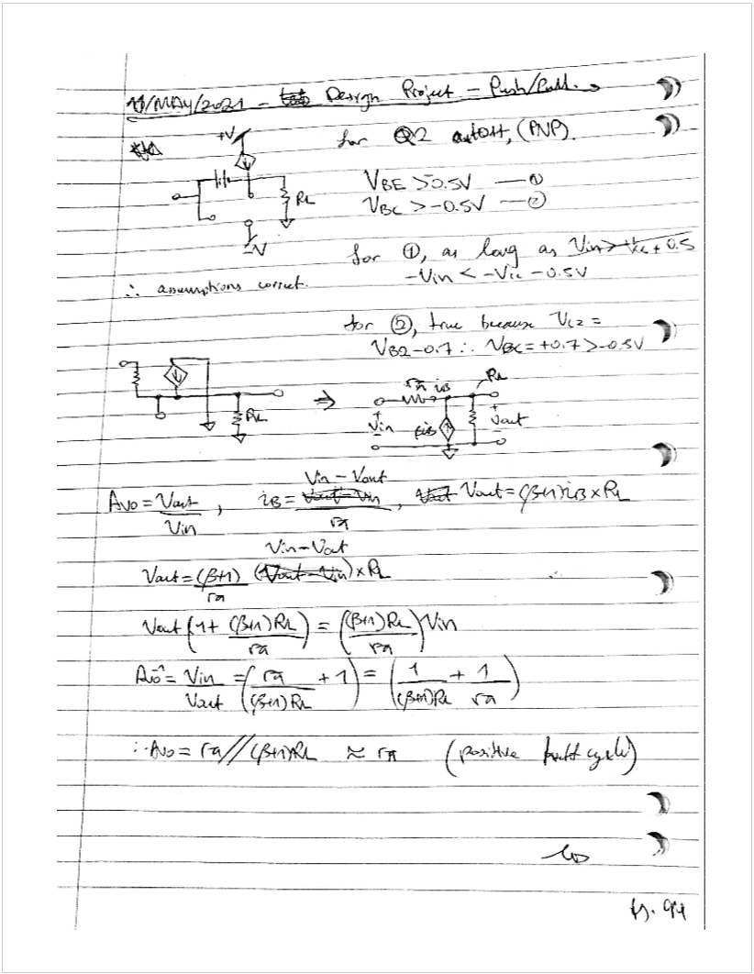

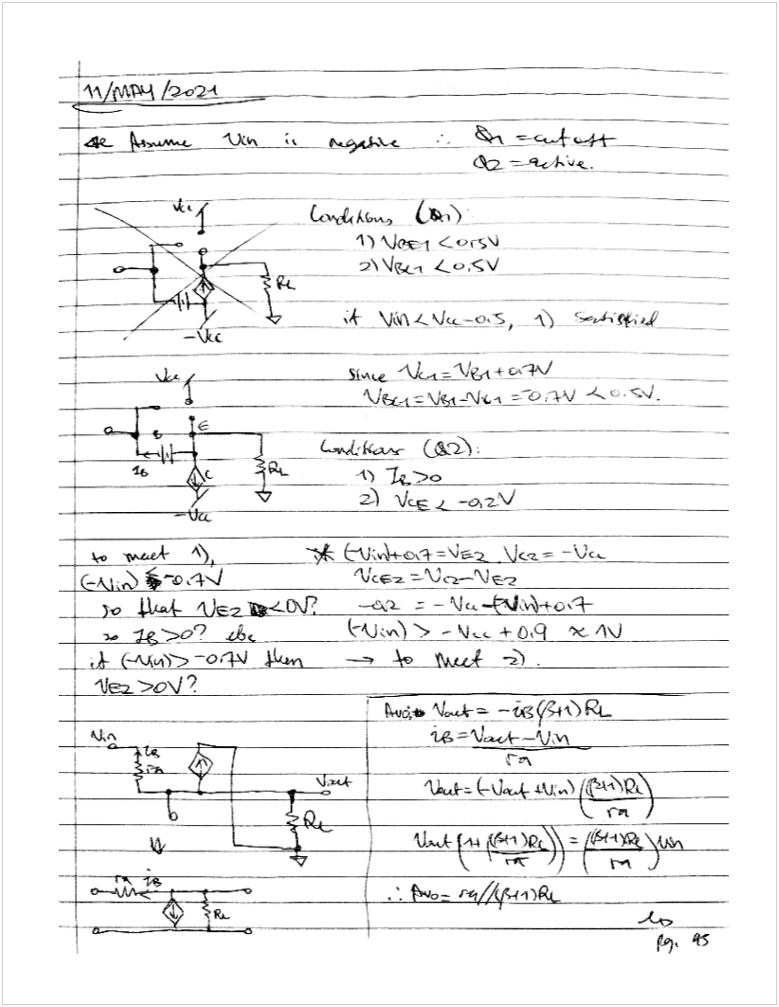

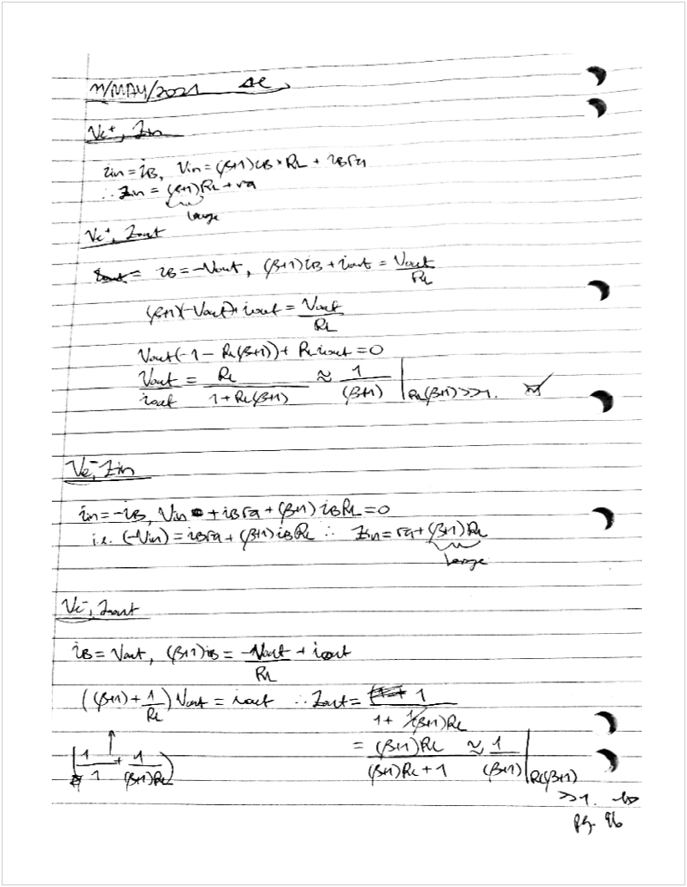

## 2.2) Key Takeaways

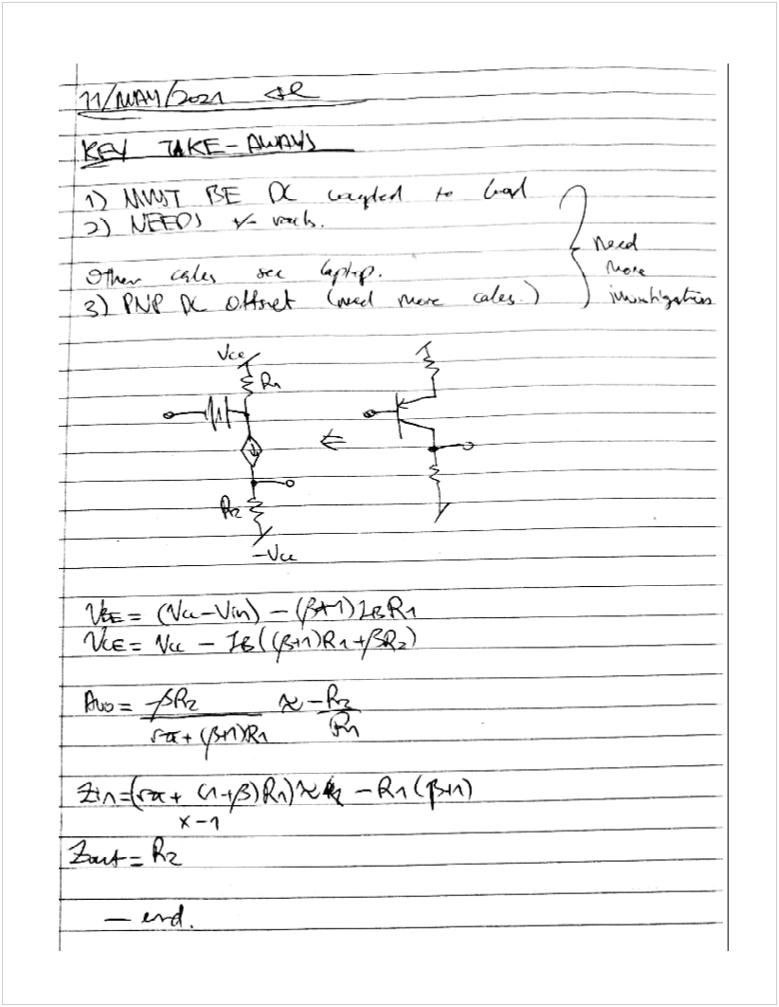

## 2.3) Component Selection

<https://pdf1.alldatasheet.com/datasheet-pdf/view/75125/MICRO-ELECTRONICS/2N2907A.html>

<https://pdf1.alldatasheet.com/datasheet-pdf/view/686484/SURGE/2N2222.html>

Q Point: 10mA, 6V

## 2.4) Simulations

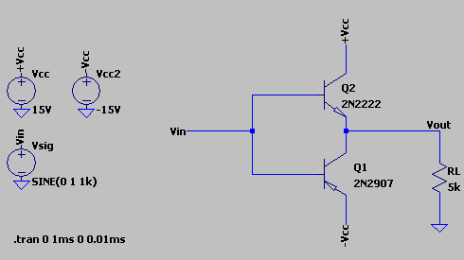

Figure 5: LTSpice Model for Basic Push Pull

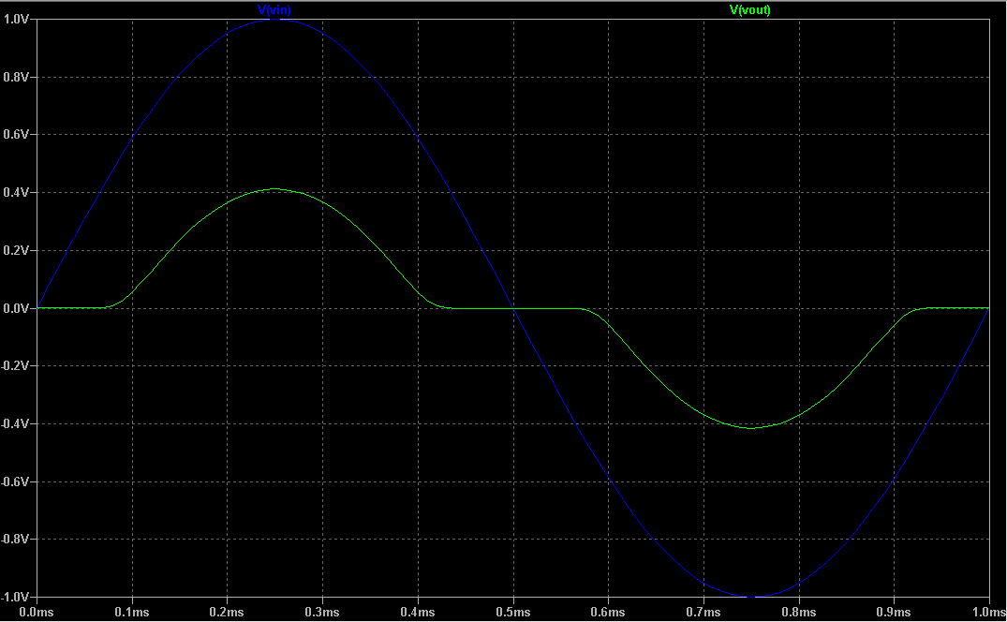

Figure 6: Crossover Distortion from Push Pull

## 2.5) Further Improvements

Need a buffer to eliminate cross-over distortion (see 2.4).

Will use a diff buffer (probably) will impact on future design (mainly current mirror but also gain and impedance matching).

# 3) Microphone Input

## 3.1) Background Research

<https://etsgstore.uqcloud.net/ows/customermedia/pdfs/10-24-01.PDF>

<https://www.analog.com/en/analog-dialogue/articles/understanding-microphone-sensitivity.html>

<https://geoffthegreygeek.com/microphone-sensitivity/>

## 3.2) Formula

Where , and the reference pressure is

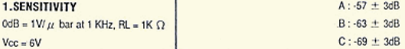

## 3.3) Summary

Microphone should output somewhere between 0.25mV to 2mV for 94dB.

I can't give more precise values because there are three types of microphone and I can't see the model printed on the device itself.

Because human speech is 40dB to 50dB, we should be expecting about 0.125mV to 1mV?

## 3.4) Wire Up

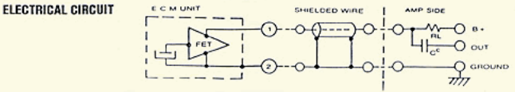

Figure 7: Microphone Datasheet Circuit Information

Assuming that the leftmost symbol is the microphone, it looks like it wants to be hooked up to:

1. A buffer stage (or our diff amp stage), into
2. A shielded wire to reduce noise from the environment, into
3. The amplifier (our single transistor cascade)

More research will be conducted

# 4) Speaker/Earphone Output

<https://au.element14.com/mcm/28-005/earphone-plug-size-3-5-mm-cord/dp/2783587?CMP=i-55c5-00001622>

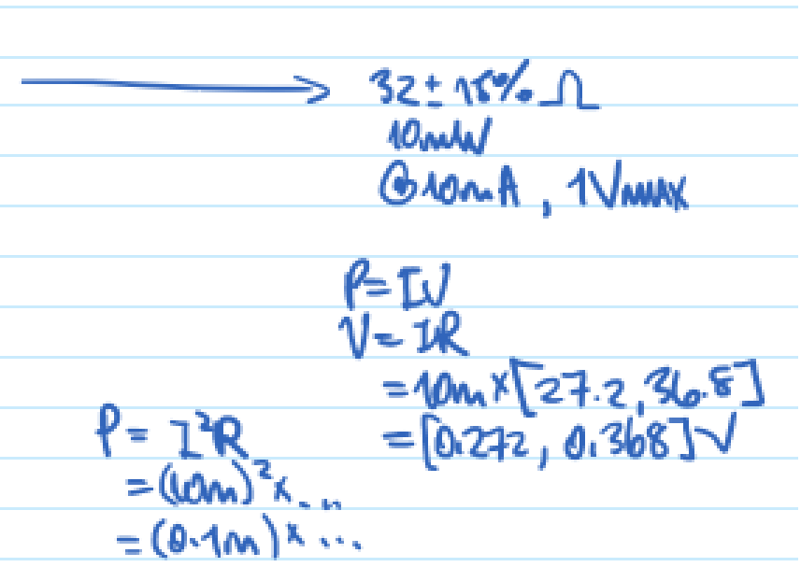

# Appendix A: Block Diagram of Circuit

